 | 7.3.16 Editors - 3D Viewport - Sidebar - Animation Tab
Table of content
View tab 3
View tab - View Panel 3
Focal Length 3
Clip Near / Clip Far 3
Use Local Camera 3
Use Render Region 3
Camera Lock 3
Lock to Object 4
Lock to 3D Cursor 4
Lock Camera to view 4
Lock View Rotation 4
View tab - Edit Panel 4
Lock Object Modes 4
View Tab - 3D Cursor Panel 4
Location 5
Rotation 5
Right Click menu 5
Reset All to Default Value 5
Reset Single to Default Value 5
Unset 5
Copy All to Selected 5
Copy Single to Selected 5
Copy Data Path 5
Copy as new Driver 5
Online Python Reference 5
Edit Source 5
View tab - Collections Panel 6
Local Collections 6
List of Collections 6
View tab - Annotations Panel 6
Annotations prop 6
Drop down box 6
Edit Box 6
Fake User 6
Add Annotation 7
Delete Annotation 7
List of Annotation Strokes 7
Opacity 7
Thickness 7
Frame Locked/Unlocked 7
Onion Skin 7
View tab - Stereoscopy Panel 8
Left / Right / 3D 8
Views / 3D 8
Cameras 8
Plane 8
Alpha 8
Volume 8
Alpha 8
Set Stereo 3D 8
Display Mode 9
Display Mode Type Anaglyph 9
Anaglyph Type 9
Display Mode Type Interlace 9
Interlace Type 9
Swap Left/Right 9
Display Mode Type Time Sequential 10
Display Mode Type Side by Side 10
Cross Eyed 10
Display Mode Type Top Bottom 10
View tab - Important Hotkeys 10
Show Text 11
Color 11
Font Size 11

Animation tab - Pose Library Panel
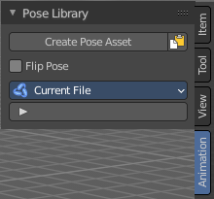
The Animation tab contains currently the pose library settings.

Create Pose Asset
This button becomes active with a armature in pose mode. It allows you to insert the current pose into the Asset browser, to reuse it at a later point.

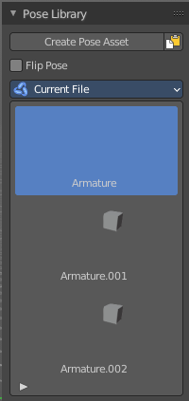
Copy Pose as Asset
Copy the current pose as an asset, which can then be pasted into an asset library.

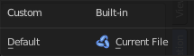
Active Asset Library
Which asset library to use. A custom one, or the built in asset lib. Default is the built-in called Current File.

List of Asset Poses
The list of available asset poses.

Search Field

You can expand a search field at the bottom of the list. Type in your term and hit enter to filter for your term.

Invert
Exclude the search term instead of searching for it.

Sort by Name
Sort the List by name.

